Things to have done before running this protocol!
- Prepared receptor using MGLTools and placed it into a folder of your choice
- Placed all ligand_pdbqt files into folder
- Determined gridbox coordinates/center (you would have done this during receptor and ligand preparation)
- Ensure AD4Zn.dat is present in folder
- Placed vina into folder
- You have downloaded AutoDock Version 4.2.6
- Have python downloaded on your computer

Step 1: Set directory:
cd C:\Users\Cwini\Downloads\IshResearch C:\Users\Ganesh\Desktop\GT_Research\Test
C:\Users\Cwini\Downloads\IshResearch

Step 2: Add tetrahedral zinc pseudoatoms
python "C:\Users\Cwini\Downloads\IshResearch \AutoDock-Vina-develop\example\autodock_scripts\zinc_pseudo.py" -r Carbonic_Anhydrase_Post_Processed.pdbqt -o Carbonic_Anhydrase_Post_Processed_tz.pdbqt

You should receive an output that says: “Wrote 1 TZ atoms on protein_tz.pdbqt.”

Step 3: Specify Gridbox and Parameter Files

You should use the gridbox dimensions and adjust the below command(s) to the gridbox coordinates you set up using the endogenous ligand
Example
python /home/user/Downloads/AutoDock-Vina-develop/example/autodock_scripts/prepare_gpf4zn.py -l ligand.pdbqt -r protein_tz.pdbqt -o protein_tz.gpf -p npts=40,30,50 -p gridcenter=18,134,-1 –p parameter_file=AD4Zn.dat

My usage
python "C:\Users\Ganesh\Desktop\GT_Research\Test\AutoDock-Vina-develop\example\autodock_scripts\prepare_gpf4zn.py" -l 16517-11-6.pdbqt -r SOD1_tz.pdbqt -o SOD_tz.gpf -p npts=14,14,14 -p gridcenter=22.389,-19.125,20.121 -p parameter_file=AD4Zn.dat

python "C:\Users\Ganesh\Desktop\GT_Research\Test\AutoDock-Vina-develop\example\autodock_scripts\prepare_gpf4zn.py" -l 16517-11-6.pdbqt -r 7q0d_Zn_pp_tz.pdbqt -o 7q0d_Zn_pp_tz.gpf -p npts="28,30,28" -p gridcenter="29.951,0.420,-4.735" -p parameter_file="C:\Users\Ganesh\Desktop\GT_Research\Test\AutoDock-Vina-develop\data\AD4Zn.dat" -p ligand_types="C,A,N,OA,HD,F" -p receptor_types="A,C,Zn,TZ,NA,OA,N,SA,HD,F"

Step 4: Run AutoGrid4 to Generate GPF File

Now, run autogrid4 to generate affinity maps.
"C:\Program Files (x86)\The Scripps Research Institute\Autodock\4.2.6\autogrid4.exe" -p "C:\Users\Ganesh\Desktop\GT_Research\Test\SOD1_tz.gpf"
Step 5: Edit the GPF file and add additional/missing atom type maps
Within NotePad, edit the gpf (protein_tz.gpf) file to incorporate Sulfur (S), and Sodium (NA) maps, as shown here:
*Highlighted parts are what you have to manually add*
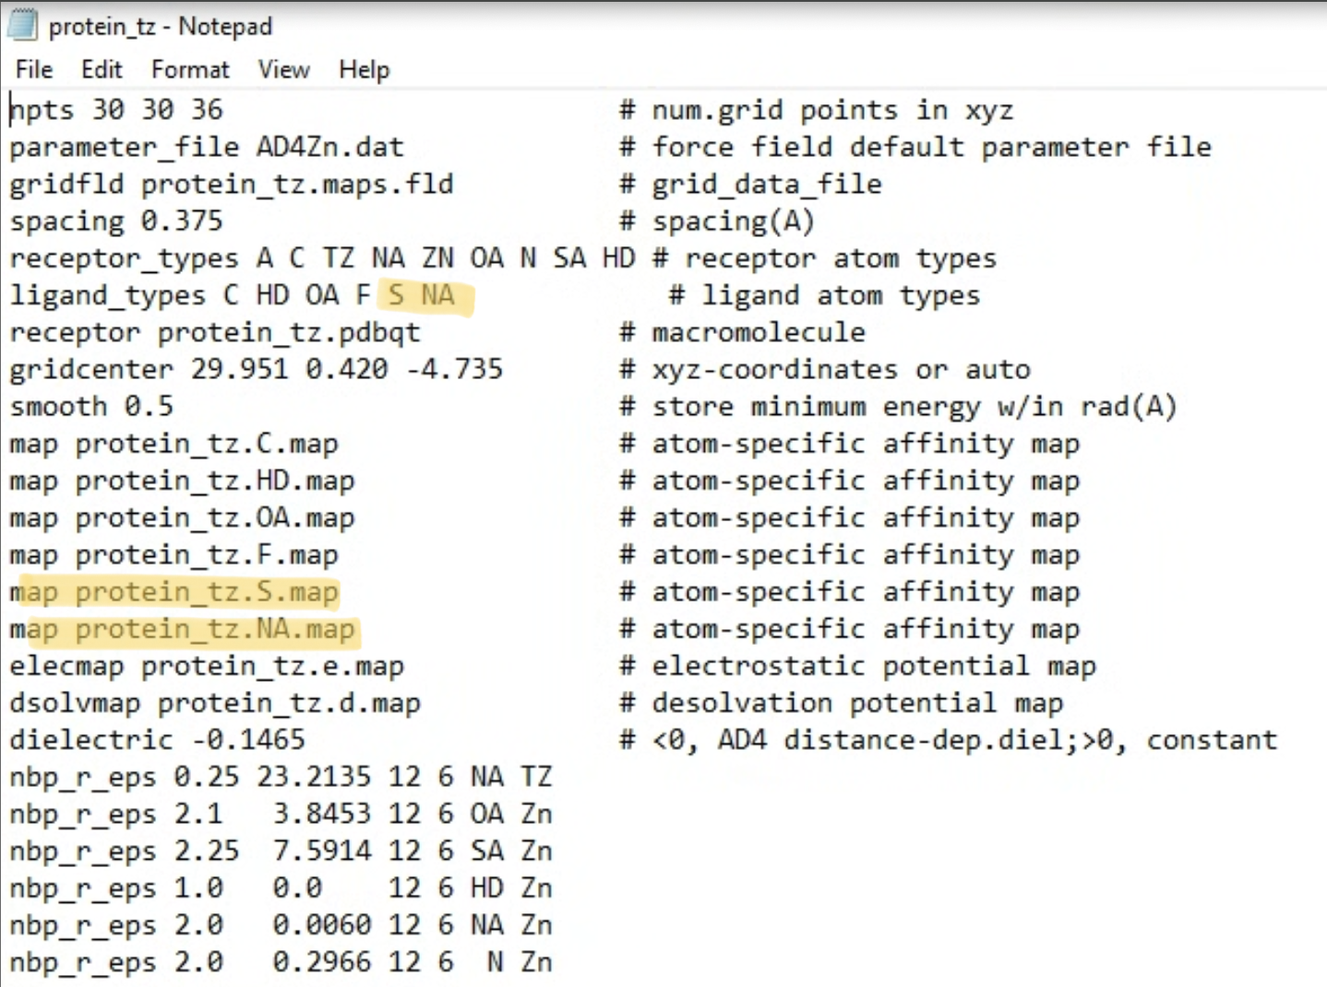

Then, run the following command in your command prompt:
"C:\Program Files (x86)\The Scripps Research Institute\Autodock\4.2.6\autogrid4.exe" -p "C:\Users\Ganesh\Desktop\GT_Research\Test\7q0d_Zn_pp_tz.gpf" -l "C:\Users\Ganesh\Desktop\GT_Research\Test\7q0d_Zn_pp_tz.glg"

Step 6: Run Docking using AutoDock Vina

For automated ligand docking for multiple ligands, run the automated_docking.py file through this command:

"C:\Users\Ganesh\AppData\Local\Programs\Python\Python313\python.exe" automate_docking.py

For individual ligand docking, run this:

vina --ligand 16517-11-6.pdbqt --maps protein_tz --scoring ad4 --exhaustiveness 32 --out whatever_output_name_preferred.pdbqt

vina --ligand 16517-11-6.pdbqt --maps 7q0d_Zn_pp_tz --scoring ad4 --exhaustiveness 32 --out 16517_11_6_TEST.pdbqt

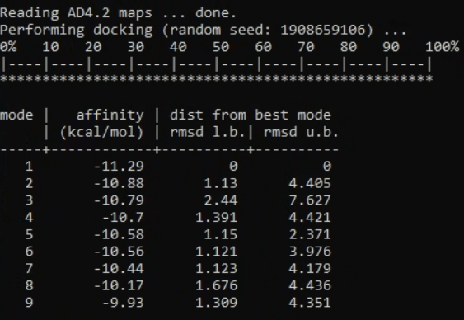

vina --ligand 16517-11-6.pdbqt --maps protein_tz --scoring ad4 --exhaustiveness 32 --out whatever_output_name_preferred.pdbqt

